JavaScript Part-3
- Scope
  - Function scope:
    - Inside function only it can be accessed
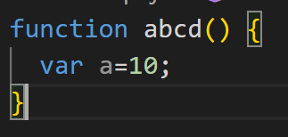
  - Global scope:
    - Entire code anywhere it can be accessed
  - Block scope:
    - {} only inside this can be accessed

- Execution Context
  - Memory phase: variables are stored
  - Execution phase: code is executed

- JS is a Lexical Scope
  - Only Can be accessed anywhere within the function
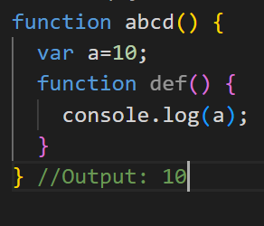
- Dynamic scope
  - Not used in JS
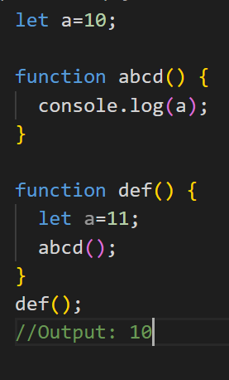

- Closures
  - Is a function which is inside parent function and the inside function is returning any parent function variable.
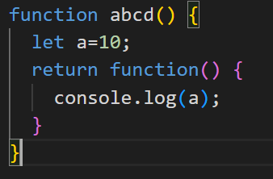
- This keyword
  - In global scope value of this: window
  - In function scope value of this: window
  - In method with function: object
  - In method with arrow function: window
  - Function inside function method: window
  - Arrow function inside method: object (always takes from parent)
  - Event handler: element
  - Class: blank object
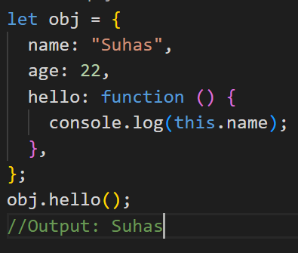
- Manual Binding
  - Call, bind, apply
  - Call
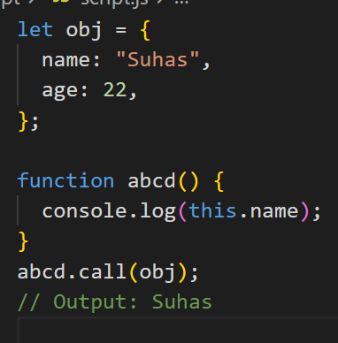

  - Apply: passes 2 values (object, values)
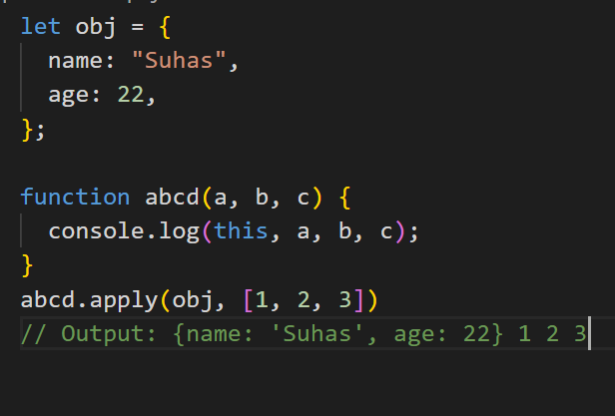
  - Bind: creates new copy by duplicating
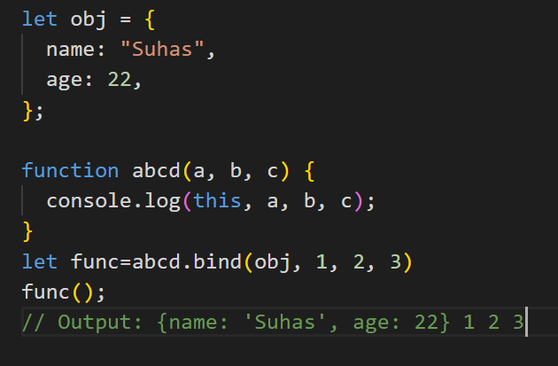
- Constructor:
  - 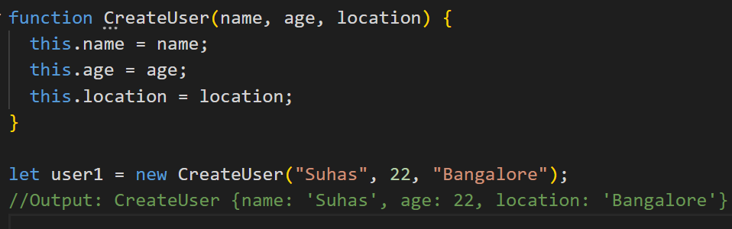

- Prototype
  - Used to add field in constructor
  - 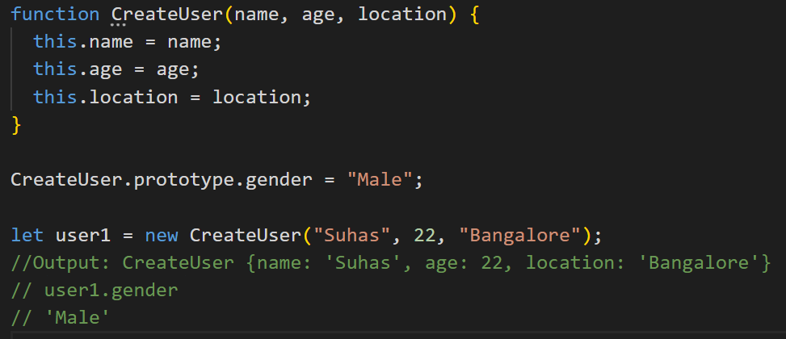

- Class
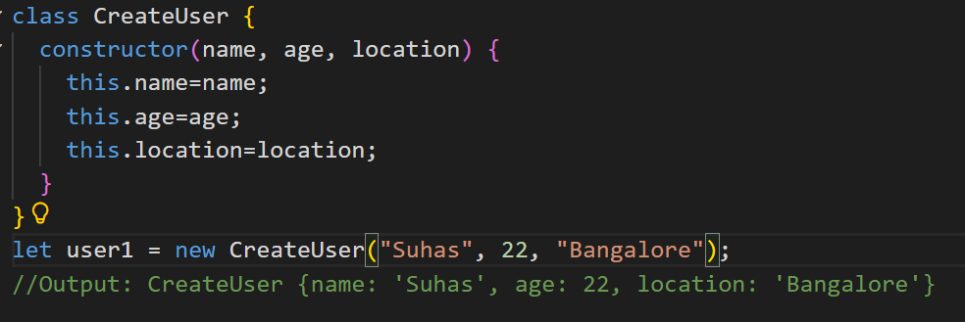
- Extends, super
  - 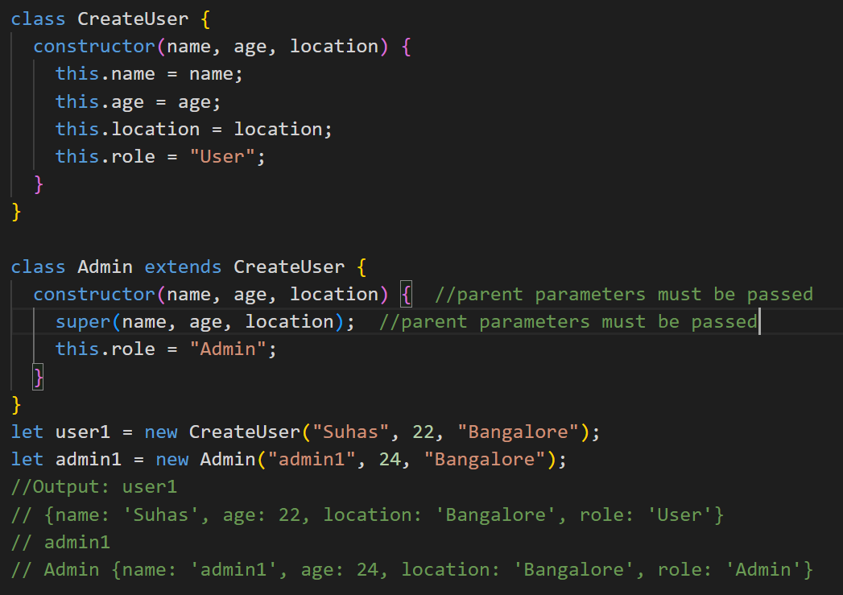

- Prototype Inheritance
  - Similar to inheritance but extra Object.create();
  - 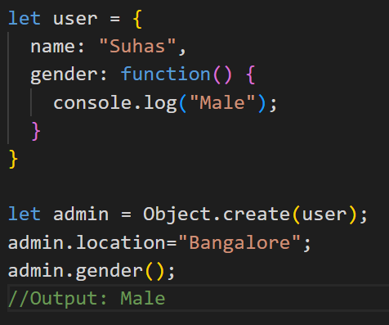

- Asynchronous
  - Sync: line by line execute
  - Async: which is ready to execute
- Callback hell
  - Callback inside callback
- Promises
  - Resolve, reject, then, catch
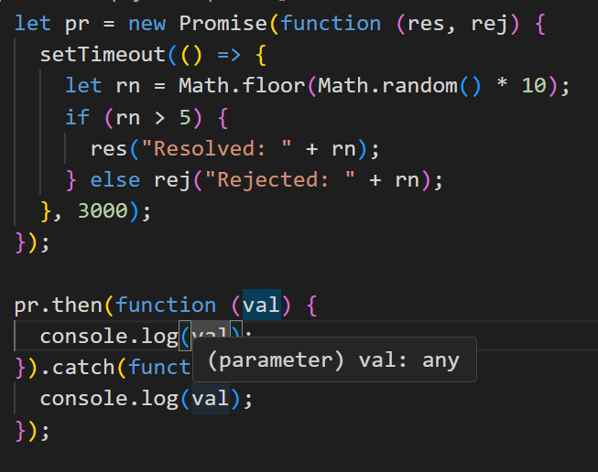

- Async & await
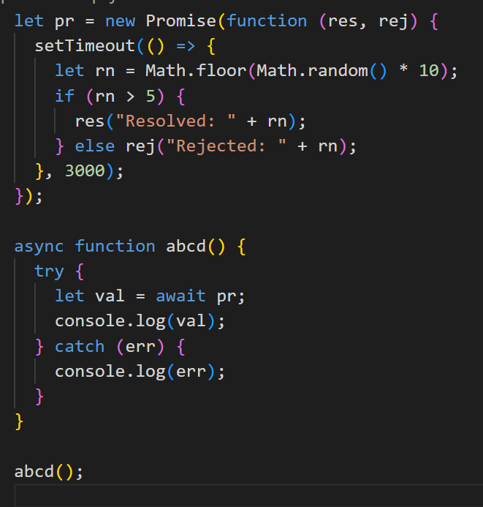
- Fetch API + HTTP Basics
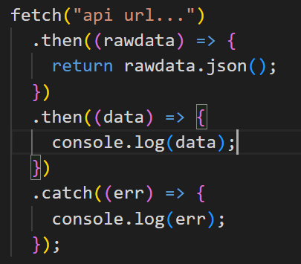
- Response Codes
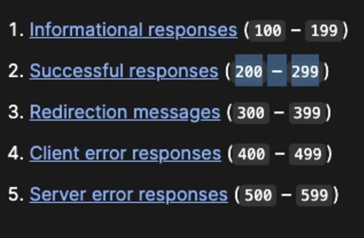

- Form Submission using fetch
- 